USING COPE AND PUNT LENGTH-BASED REFERENCE POINTS TO ASSESS AND MANAGE DATA-LIMITED FISH STOCKS

Rod Fujita, Kendra Karr and Ashley Apel

Research and Development Team

Oceans Program, Environmental Defense Fund

July 2012

Tel: (415) 293-6050 Email: rfujita@edf.org

# Introduction

It is important to assess fishery stock status in order to set catch limits and reduce the risk of stock collapse and associated adverse social and economic impacts. Assessments, however, are difficult in data-limited fisheries. In such fisheries, it may be useful to first calculate simple indicators of stock status based on the distribution of harvested fish in each size category; data which are relatively easy to collect (Froese 2004). No lengthy data records are necessary to support these calculations, making this method particularly suitable for fisheries that have no or little history of monitoring.

Froese’s previously developed, easy to use methods were proposed to avoid growth and recruitment overfishing, but there was no connection to stock status and calculation of future sustainable catches. To make this connection, Froese’s (2004) methods were extended by Cope and Punt (2009) to examine the influence of fishing mortality and spawning biomass (SB). This extension assessed the Froese method's sensitivity to fishery selectivity, life history traits, and recruitment compensation into the development of size-based reference points, ultimately establishing a critical link between the identification of trends and the design of harvest control rules with a decision tree. Ultimately, using easy-to-gather catch-length data, the Length-

Based Reference Point model (LBRP; Cope and Punt 2009) provides managers with an assessment tool that evaluates whether a stock’s spawning biomass is at or above a specified reference point.

Here we provide a step-by-step guide for a decision tree analysis to assess stock sustainability using LBPR (Cope and Punt 2009). Data inputs include the proportion of the catch in a given length class (L), length at 50% maturity, maximum length, and the length at which a stock’s cohort provides the highest yield. These inputs are then used to calculate the number of mature fish, optimally sized fish, and large, highly fecund females in a population (Froese 2004). These indicators are based on the observation that overfishing changes the length-frequency of populations and removing too many juveniles or too many large, fecund fish threatens the sustainability of fish populations.

The LBRP method can be used even in the absence of data concerning mortality, fishery selectivity, and recruitment. Due to the use of specific size classes, this model may not be appropriate for stocks that exhibit little difference between mature (small) and optimum (medium) individuals. Additionally, the collection of basic biological parameters related to growth and maturity are used to assess a range of fishery conditions on the future sustainability of a stock.

**Note on length- based methods and gear:** Because length-based methods like this one depend on the assumption that the reduction in the numbers of fish in the above average size classes is due only to mortality, it’s important to ensure that the gear or the way it is being used is not causing peaks in certain size classes, or otherwise affecting the length-frequency composition. Another way to think about this is to regard the catch as a sample of the population of fish and ask: is this sample likely to be representative of the true length composition of the population? If there are good reasons to believe that it is not (for example, fishers are discarding smallest individuals before they can be counted in the catch), then length-based methods may not be appropriate for your data.

# Description of Size-Based Sustainability Indicators (Px)

An overview of the three size-based sustainability indicators (Froese 2004) are described below: percentage of mature fish in the catch (Pmat), percentage of fish caught at the optimum length for harvest (Popt), and percentage of mega-spawners in the catch (Pmega); collectively referred to as **Px[1]**.

*Pmat:*  measured as the percentage of mature specimens in the catch (i.e., length at 50% mature). Mature individuals are defined as those which have had a chance to spawn at least once. The target is to let all (100%) fish spawn before being caught (i.e., zero catch of juveniles) to rebuild and maintain healthy spawning stocks.

*Popt:* the percentage of fish caught at optimum length. Optimum length is where the number of fish in a given unfished year class multiplied by their mean individual weight is highest, resulting in maximum yield/revenue. Optimum length is typically a bit larger than length at first maturity and can be easily obtained from growth and mortality parameters or empirical equations (Froese and Binohlan 2000). The target is to have all harvested fish (100%) be within +/- 10% of optimum length (see Fig. 1).

*Pmega:* the percentage of old, large fish (mega-spawners) in the catch (optimum length plus 10%). The target is to harvest no (0%) mega-spawners. If the catch reflects the age and size structure of the stock, however, 30-40% of mega-spawners in the catch would likely reflect a healthy population; 20% of mega-spawners would be cause for concern and should be the lower limit. There are numerous examples of why large and older fish play an important role in the long-term survival of a population:

1. Large females are much more fecund because the number of eggs increases exponentially with length in most species; their eggs also tend to be larger, thus giving a greater chance of survival to larvae.
2. Reaching old age is usually a sign of overall individual fitness and thus mega-spawners are reservoirs and distributors of desirable genes.
3. Extending longevity and prolonging the reproductive phase can be viewed as a natural safeguard against subsequent recruitment failure.

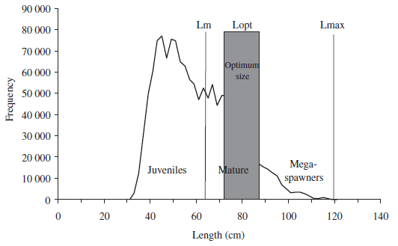

**Figure 1:** Length-frequency data of Western cod landings from 1994-2001, where *Lm* indicates length at first maturity, *Lopt* indicates the length range where maximum yield could be obtained, and *Lmax* is the maximum size reached during that time (Froese 2004).

# Calculating Sustainability Indicators (Px)

**Step 1**: **Getting Started**

1. Target Species:
   * Identify a target species where you have length-frequency data from catch surveys and a good idea about the maximum length of the population (the largest fish caught during the past 5-10 years), either from fishermen’s observations or monitoring.
   * If maximum length is unknown, data can be gathered from online resources such as FishBase.
2. Excel Spreadsheet:
   * Use the Excel spreadsheet to keep track of the parts of the analysis and the results from the Length-Frequency Analysis Wizard, see attached (LF_Anlaysis.exl).
3. Length-Frequency Analysis:
   * The Length-Frequency Analysis Wizard needed to perform these calculations is available online at FishBase (<http://www.fishbase.org>). The software is accessible by choosing a target species, then clicking *length-frequency wizard* under the *Tools* category.

**Step 2: Input Data**

Input the following data into the Analysis Wizard:

1. Maximum length known for the population and the respective length type (total length (TL), standard length (SL), or fork length (FL)). Total length is needed to calculate natural mortality at a later stage.
2. Size-frequency of the catch

The sampling program should be designed to ensure that the size class distribution is as broad as possible, preferably with data being obtained in all seasons (or including the seasons where there were more fishing activity reported ), from all fishing zones and including all types of fishing gear. The major assumption is that the catch length composition is representative of the fishery catch at length.

Measurements should be done with reasonable precision. As a rule-of-thumb, a precision of 1 cm is adequate for species for which most fish are 30 cm or bigger. A precision to 0.5 cm at the time of measuring is fine for fish from 15 cm upwards, and so on for smaller individuals. Data should be grouped into length-classes of usually 20–40 groups. However, if fish sizes in size ranges are smaller, for example from 10 to 25 cm, a precision of 0.5 cm should be used (this will give 30 groups).

The amount of sampling in a stratum (different areas, habitats, etc.) should be proportional to the contribution of that stratum to the total variability, (greatest in those with the larger landings or with more variable sizes).

Samples of the catch should be random and include at least 500 fish for each species, of the greatest variety of boats, gear types, and landing dates possible to maximize the range of lengths sampled. If the length-frequency data come from a single sample, the dataset should include at least 1,000 specimens. A good sample would be accumulated over a minimum of six months and include over 1,500 specimens. Additionally, monthly samples should contain roughly the same number of fish surveyed.

**Step 3: Length-Frequency Graph**

Once the maximum length and size-frequency data are entered, the Analysis Wizard provides the following:

1. Length at optimum yield (Lopt)
2. Length at first maturity (Lm)
3. Number of specimens in the sample
4. *Pmat*; number of mature fish in the sample and percent of sampled population
5. *Popt*; number of specimens at optimum yield and percent of sampled population
6. *Pmega*; number of mega-spawners in the catchand percent of sampled population
7. Smallest fully selected length class
8. Average length in the sample

The Analysis Wizard also provides an output graph that shows the length-frequency data with vertical lines depicting maximum length, length at first maturity, and length at optimum yield. The graph can be used to monitor progress toward specific management targets.

**Alternative Calculation Method**

As an alternative to using the Analysis Wizard online, the equations in Figure 2 can be used to calculate Pmat, Popt, and Pmega using length data from the catch.

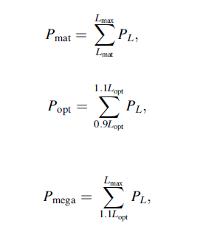**Figure 2:** Equations to calculate Pmat, Popt, and Pmega using length data from the catch.

# PL: the proportion of the catch from a specific length class

* Lmat: the length at 50% maturity
* Lmax: the maximum length of the species
* Lopt: the length at which maximum yield can be obtained

# Creating a Harvest Control Rule Using Size-Based Reference Points and a Decision Tree

The LBRP method improves on simpler length based sustainability indicators by adding a new measure, Pobj, which is used to distinguish between fishery selectivity patterns and construct a decision tree for modification of the sustainability indicators; Pmat, Popt, and Pmega. Decision trees are step-by-step decision-making tools that can be scaled to fit any management framework and stock size. Given catch data and life-history characteristics, managers can use decision trees to examine trends in the population and better implement harvest control rules.

To use the decision tree, Pmat, Popt, and Pmega are calculated by using length composition and life history values (see above for details). The sum of these values gives the Pobj value, which describes the selectivity of the fishery (noted in gray boxes of Fig. 2). Following the tree all the way down, the corresponding value of either Pmat or Popt is interpreted to determine whether the spawning biomass (SB) is at or above the target reference point (RP). A decision tree can be applied even if direct information on mortality, fishery selectivity, and/or recruitment is lacking. If the Pobj value < 1, this is indicative of selectivity patterns that do not follow Froese’s (2004) sustainability recommendations. A Pobj value > 1 is indicative of selectivity patterns that do follow Froese’s (2004) sustainability recommendations (Figure 3). Figure 3 provides a set of rules for defining when a stock is below the total or limit reference point.

What is the value of Pobj?

1. Pobj is < 1: determine the interaction of Popt and Pmega
   1. Popt and Pmega = 0: the fishery is one that fishes only immature individuals (Pmat > 0.25) and is considered highly undesirable under Froese’s (2004) sustainability recommendations.
   2. Popt and Pmega > 0: the fishery is one that fishes small and optimally sized or all but the biggest individuals and is considered undesirable.
2. Pobj is > 1 and < 2: the fishery is one that fishes some immature and sub-optimally sized fish and is considered desirable under Froese’s (2004) sustainability recommendations.
3. Pobj = 2: determine the value for Popt
   1. Popt < 1: the fishery is one the fishes optimally sized and bigger individuals and is considered desirable.
   2. Popt = 1: the fishery is one the fishes optimally sized individuals and is considered desirable.



**Figure 3:** Decision tree for defining indicator values (boxes) of stock status above spawning biomass (SB) reference points by using length composition data. The main decisions relate to selectivity type (distinguished by the *Pobj* value), the ratio of length at maturity (*Lmat*) to optimal fishing length (*Lopt*), and recruitment compensation (measured by steepness; from Cope and Punt 2009). An ogive is a distribute curve.

# Cautions and Caveats of Size-Based Reference Points

The following describes a few caveats to the LBRP method.

1. Depletion of mega-spawners from fishing mortality can falsely suggest the fishery is catching “optimum” (medium) individuals.
2. LBRP may not be appropriate for stocks with low steepness because of little difference between “mature” (small) and “optimum” (medium) individuals.
3. Simple assessment methods like this (based on maintaining conservative levels of spawning biomass) are helpful, but do not directly translate to harvest control rules.
4. The accuracy and statistical power of decision tree outputs depends strongly on the quality of data inputs and underlying model assumptions.

# Appendix 1

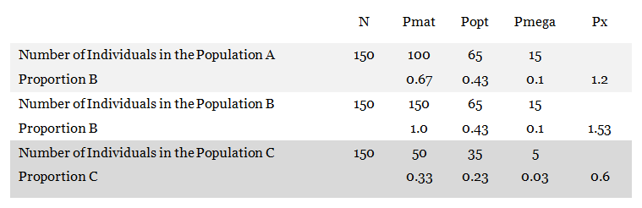

# References

Cope, JM and AE Punt 2009. Length-Based Reference Points for Data-Limited Situations: Applications and Restrictions. Marine and Coastal Fisheries: Dynamics, Management, and Ecosystem Science 1:169–186

Froese, R. 2004. Keep it simple: three indicators to deal with overfishing. Fish and Fisheries 5:529 86-91.

Froese, R., and D. Pauly. 2012. FishBase. World Wide Web electronic publication: www.fishbase.org.

Froese, R., and C. Binohlan. 2000. Empirical relationships to estimate asymptotic length, length at first maturity and length at maximum yield per recruit in fishes, with a simple method to evaluate length frequency data. Journal of Fish Biology 56:758-773.

1. Collectively, each metric of Px can be < 1. Therefore, Px can be > 1, see Appendix 1.